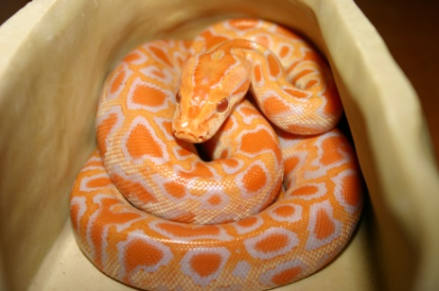
Holly is an

Albino Burmese Python

- The Burmese python is found throughout South-East Asia, Burma, Sumatra, Borneo and Malaya.
- They usually live near water and will inhabit grasslands, marshes, swamps, rocky foothills, woodlands, river valleys and jungles with open clearings.
- Burmese pythons prey on small mammals, up to the size of a pig or small deer; however, smaller snakes will eat birds, lizards, other snakes, frogs, and even fish.
- Burmese pythons are usually nocturnal hunters and often ambush their prey with a sit and wait technique.
- They require little more than their own body weight of food per year.
- The Burmese python lays on average between 20 and 60 eggs about 3-4 months after mating.
- The female will coil her body around the eggs to protect and incubate them. She uses muscular contractions, similar to shivering, to keep her body temperature several degrees above that of the surrounding air.
- The female will incubate the eggs for 60-80 days.
- Burmese Pythons constrict their prey. This involves the snake tightly coiling around the prey, not crushing it, but severely restricting movement.

