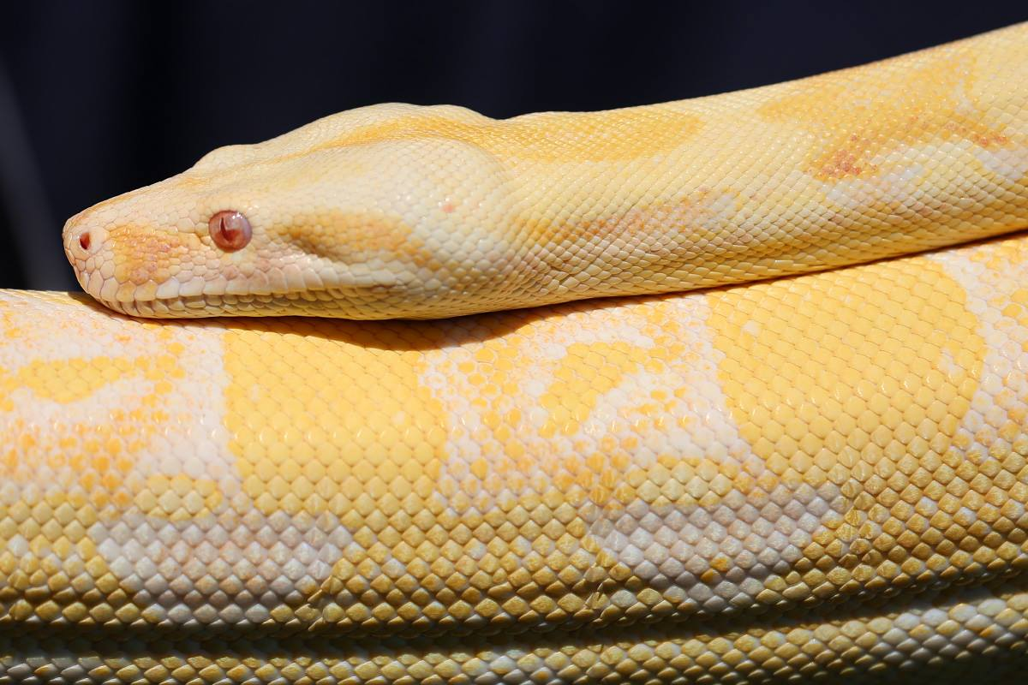

Marmaduke is an

Albino Boa Constrictor

- South American, found from northern Mexico to Argentina. They may also be found on some islands in the Caribbean.
- Boa Constrictors are one of the largest snakes in the world
- They are 20 inches (50 cm) as babies to 13 feet (3.9 m) as adults. With the females being larger
- The longest ever recorded Boa Constrictor is said to have been 18 feet long, that’s over 3 times as long as you or me if you are about 5 feet tall.
- They usually weigh between 60 and 100lbs (45 kilograms) or more once fully grown.
- The natural lifespan of a boa constrictor can average around 35 years. The oldest known boa lived to 40 years and 4 months.
- Boa constrictor is nocturnal animal (active during the night)
- Boas are non-poisonous
- Boa Constrictors vary in colour from a pinkish brown to grey with distinguished markings called ‘crossbands’ along their body. Their patterns can vary to match their environment.
- Boas, live in the most varied habitats, It lives in deserts, wet tropical forests, open savannah, and cultivated fields,
- Boa constrictors are as happy on the ground or in trees
- Although they are excellent swimmers they don’t enjoy water
- In the wild Boas feed on large lizards, small or moderate-sized birds, bats, mongooses, rats, and squirrels.

- Their jaws are lined with small, hooked teeth for grabbing and holding prey while they wrap their muscular bodies around their victim
- Boa Constrictors use constriction to suffocate their prey. When the prey has been suffocated the Boa eats it whole. It can take several weeks for a Boa to digest its food completely.
- Their jaws can stretch wide to swallow large prey whole.
- It is a nocturnal hunter and uses its heat-sensitive scales to locate its prey in the dark.
- They ambush their prey, which means that they will hide and wait for something yummy to go by and then do a surprise attack.
- Boa Constrictors have bad eyesight.
- A Boa smells with its tongue. When a snake wants to smell its surroundings it will flick its tongue out and gather the particles in the air. The tongue then returns to the mouth and the tips of the tongue are pushed up against the roof of the mouth where they must enter two pits in the roof into the Jacobson's organ, which is a special organ inside the mouth for smell.
- Since these pits are split apart from each other the tongue itself also has to split. This is why snakes have forked tongues.
- Female boas of the species can give birth to as many as 50 young at any one time. Unlike many other reptiles and snakes, they give birth to live young instead of laying eggs.
- Young boa constrictors are born with instinct to hunt. They are left on their own from the moment of birth.
- The Boa constrictor is the only animal whose taxonomical (Latin) name is the same as its common name boa constrictor.
- Since boa’s are excellent hunters, the people of South America have kept Boas as pets for hundreds of years to help keep down pests, such as rodents.

